**3. Write an algorithm and program in to implement Bubble sorting**

**i) Using arrays**

**ii) Using recursion**

**(i)Using array:-**

#include<stdio.h>

main()

{

int i,n,j,temp,a[20];

printf("\n enter no. of elements=");

scanf("%d",&n);

printf("\n enter elements=");

for(i=0;i<n;i++){

scanf("%d",&a[i]);

}

for(i=0;i<n;i++){

for(j=0;j<n-i;j++)

{

if(a[j]>a[j+1]){

temp=a[j+1];

a[j+1]=a[j];

a[j]=temp;

}}}

printf("\n sorted array=");

for(i=0;i<n;i++)

{

printf("%d\t",a[i]);

}}

**Output:-**

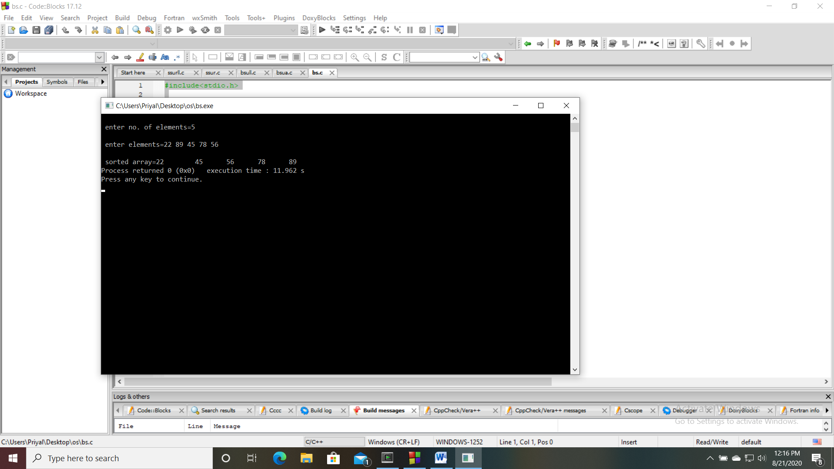

**(ii) Using recursion:-**

#include<stdio.h>

main()

{

int n,a[20];

printf("\n enter no. of elements=");

scanf("%d",&n);

for(int i=0;i<n;i++){

scanf("%d",&a[i]);

}

bsort(a,n);

printf("\n sorted array=\n");

for(int i=0;i<n;i++){

printf("%d\t",a[i]);

}}

void bsort(int a[],int n)

{

int i,temp;

if(n==1){

return;

}

for(i=0;i<n-1;i++){

if(a[i+1]<a[i]){

temp=a[i];

a[i]=a[i+1];

a[i+1]=temp;

}}

bsort(a,n-1);}

**Output:-**

